DAY 3 REPORT – DATA PIPELINE
Title: Brain Tumor Detection using Deep Learning

1. Objective
The objective of Day 3 is to build a data pipeline by splitting the dataset into training, validation, and testing sets, implementing data generators, and applying data augmentation techniques to improve model generalization and reduce overfitting.

2. Data Pipeline Overview
In this stage, the dataset is structured into efficient pipelines using generators. These pipelines load images in batches during training, improving memory efficiency and enabling real-time data processing.

3. Train / Validation / Test Split
The dataset was divided into three parts:
- Training Set: 70%
- Validation Set: 15%
- Test Set: 15%
Stratified sampling was used to maintain class balance across all splits.

4. Data Generators
TensorFlow’s ImageDataGenerator was used to create data generators.
These generators:
- Load images dynamically from disk
- Process images in batches
- Enable efficient memory usage
- Support real-time augmentation
Three generators were created:
- Train Generator
- Validation Generator
- Test Generator
Generators avoid loading the entire dataset into memory, making the pipeline efficient and scalable.

5. Data Augmentation
To improve model robustness and reduce overfitting, the following augmentation techniques were applied:
- Rotation: Images rotated up to 10 degrees
- Zoom: Zoom range of 10%
- Horizontal Flip: Images flipped horizontally
- Width & Height Shift: Small positional variations applied
These transformations simulate real-world variations in MRI images.

6. Batch Processing
Images were processed in batches:
- Batch Size: 32
- Image Size: 224 × 224
Output shape of each batch:
(32, 224, 224, 3)

7. Class Label Mapping
The generator automatically assigns labels based on folder structure:
- Brain Tumor → 0
- Healthy → 1
This mapping is used during model training.

8. Data Visualization

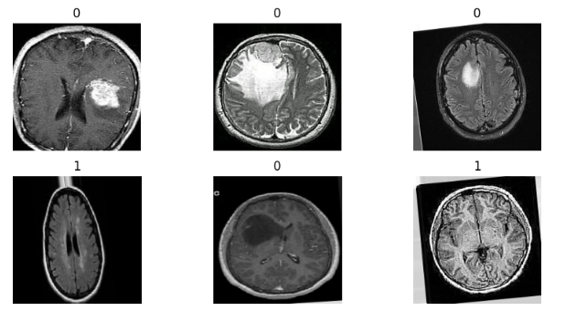
Sample images from the training generator were visualized to verify correct image loading, augmentation, and labeling. Tumor images show irregular bright regions, while healthy images appear more uniform.
- Correct image loading
- Proper augmentation
- Accurate labeling

9. Real-World Insight
In medical imaging, datasets are often limited in size. Data augmentation plays a critical role in improving model generalization and preventing overfitting.

10. Challenges Identified
- Handling dataset paths across environments (Kaggle vs Colab)
- Debugging generator setup
- Ensuring correct folder structure
- Managing memory efficiently

11. Output Summary

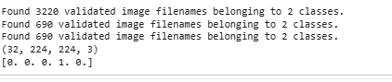

Train Generator: 3220 images

Validation Generator: 690 images

Test Generator: 690 images

Batch Shape: (32, 224, 224, 3)

Labels: Binary classification (0 and 1)

12. Conclusion
The data pipeline has been successfully implemented using TensorFlow generators. The dataset is now properly split and augmented, making it ready for training deep learning models. This pipeline ensures efficient data handling and improved model performance.
This pipeline design is scalable and suitable for real-world medical imaging applications.

13. Next Step
In Day 4, a baseline CNN model will be built and trained using this data pipeline to evaluate initial performance.

STORYBOARD
- Input: MRI Brain Images
- Preprocessing: Resize and label preparation
- Data Pipeline: Train/Validation/Test split + augmentation
- Model: CNN training
- Output: Tumor / No Tumor prediction
- Deployment: Real-time prediction system

DAILY TASK REPORT

What I did today:
- Split dataset into train, validation, and test sets
- Implemented data generators
- Applied data augmentation techniques
- Verified batch outputs and shapes
- Visualized sample images

What I will do next:
- Build baseline CNN model
- Train model using generators
- Evaluate model performance

Issues:
- Dataset path handling across environments
- Understanding generator workflow
- Debugging pipeline errors

